Current alignment techniques and tools for building, aligning, and reconfiguring an optical array at the Navy Prototype Optical Interferometer

James H. Clark III∗ª, Joshua P. Walton^{b}
ªNaval Research Laboratory/NPOI, 10391 W Naval Observatory Road, Flagstaff, AZ, 86001, USA;
^{b}Interferometrics Incorporated, 447 Lake Mary Road, Flagstaff, AZ, 86001, USA

ABSTRACT

There are a total of one hundred seventy precision flat mirrors within the optical array at the Navy Prototype Optical Interferometer (NPOI). During the build phase each mirror center is positioned in space relative to a primary fiducial. Prior to nightly astronomy observations each mirror train, up to six trains containing ten mirrors each, are checked and finely adjusted if necessary. The facilitation of diverse science programs and expanding capabilities at the NPOI require reconfigurations of optical mounts. As part of this process, alignment of the reconfigured optical train is performed. Similar tools and techniques are in use for each of these three processes. A light emitting diode (LED), mounted on a motorized target arm is strategically attached to each mirror’s mount for viewing the mirror’s center point. A focusable precision alignment telescope mounted in a precision v-block assembly is employed as the basic alignment tool. The human eye is the detector. In this paper, we describe the current tools and techniques used at the NPOI to achieve the requisite alignment tolerances and validations during the build, operations, and reconfiguration phases. We also discuss the development of alignment tolerances, the deficiencies of the current tools and techniques, issues with digital imaging and centroiding, and efforts to enhance, quantify, and validate the alignments.

Keywords: optical alignment, optical interferometry, remote control, vacuum system, NPOI

INTRODUCTION
1.1 Objectives

We describe in this paper the alignment techniques and tools used to align the optical train of the NPOI feed beam system. Alignments are conducted during the build, reconfiguration, and operations phases throughout the life of the interferometer--the techniques are similar for all three. We develop the alignment tolerances relative to vignetting and path length consistency, and relate these to the tools presently in use. Repeatable and verifiable results are necessary in order to assure reliable alignments. We discuss the deficiencies of the current tools and techniques as they relate to our efforts to quantify, validate, and enhance alignment of the system.

1.2 Feed beam system and layout

The Navy Prototype Optical Interferometer (NPOI)¹, located in Flagstaff, Arizona, consists of a y-shaped array of stellar light collecting (siderostat) stations (Fig.1). Thirty-four stations presently exist on the array, of which six may be used simultaneously for imaging programs², and four for astrometry measurements. Six siderostats and their first relay mirror, the narrow angle tracker (NAT), are dedicated to imaging programs and are portable. Their locations along the arms may be changed in order to enhance imaging data collection. A maximum of three siderostats can occupy stations along an individual arm. Thirty, of the thirty-four stations are available for imaging programs. Four siderostats, and their associated NATs, are at fixed locations and are primarily for astrometry measurement programs. The fundamental NPOI light-path layout consists of the main feed arms, periscope hubs, and long delay lines (Fig. 2). This evacuated system, collectively referred to as the feed beam system, and is designed to transmit light beams, 5-inches in diameter, from one end to the other without vignetting. There are 10 relay mirrors between each siderostat and the beam combiner room, which is the terminus of the feed beam system. Each mirror is flat (no power) and focus is a non-issue. When utilizing the full 6-siderostat imaging instrument, 60 feed beam mirrors must be in proper alignment (Fig. 2).

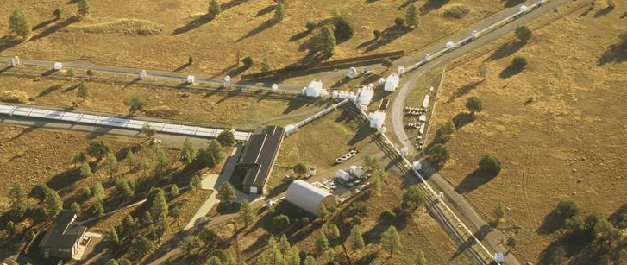

Fig. 1. Aerial view of NPOI site showing y-shaped array, siderostat stations, and long delay lines (Photo courtesy of Michael Collier).

Fig. 2. Schematic of light path of a single feed beam. There are ten reflections from the siderostat and exit of LDL manifold mirrors. A total of six such light paths occur when operating six siderostats simultaneously.

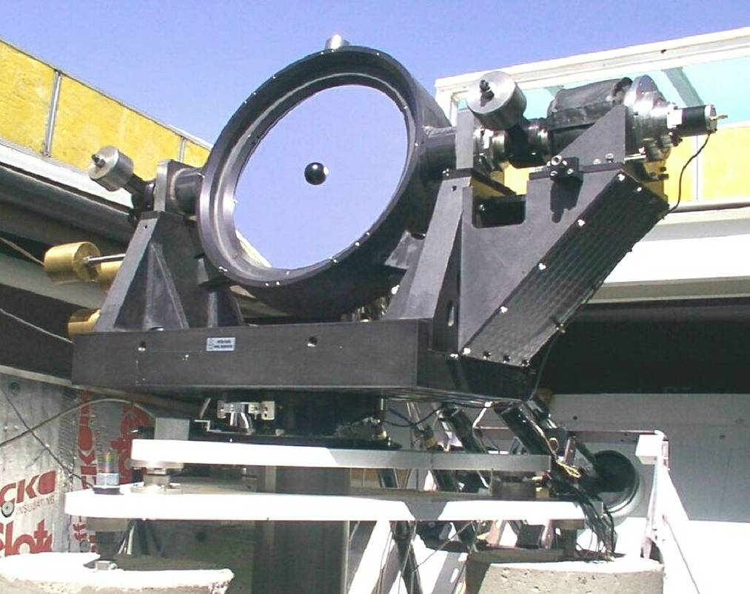

Fig. 3. Siderostat.

The arms of the array contain mirror relay stations (elevator and array center mounts). Here, the necessary changes in light path take place for the transfer of light from the siderostats to the periscope hub. The three arms are on the order of 218 meters in length, with 11 siderostat stations per arm. This portion of the system requires four reflections between each siderostat and periscope hub. The periscope hub consists of six periscopes. Each periscope, through two reflections, lowers and rotates the light beam to a long delay line station (Fig. 4). A long delay line contains six stations along its 110 meter length; each station consists of two independent pop-up mirrors adjacent to one another³. There are six long delay lines, corresponding to the maximum of six siderostats that the NPOI can simultaneously operate. The long delay line and the periscope reflect light back and forth in a “W” pattern through three reflections, at which point a final reflection within the periscope exits the beam to the beam combiner room (Fig. 5).

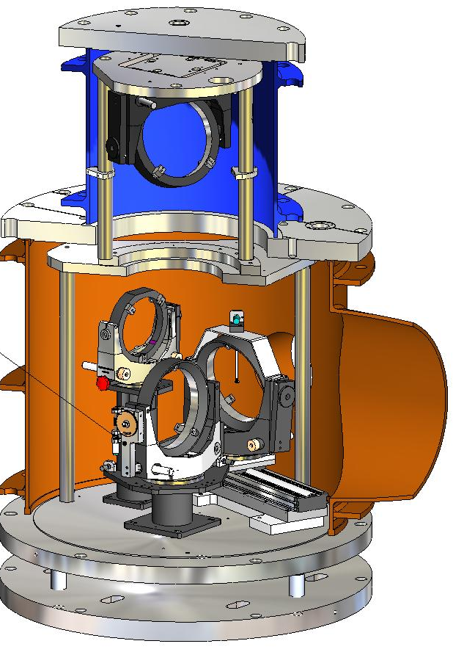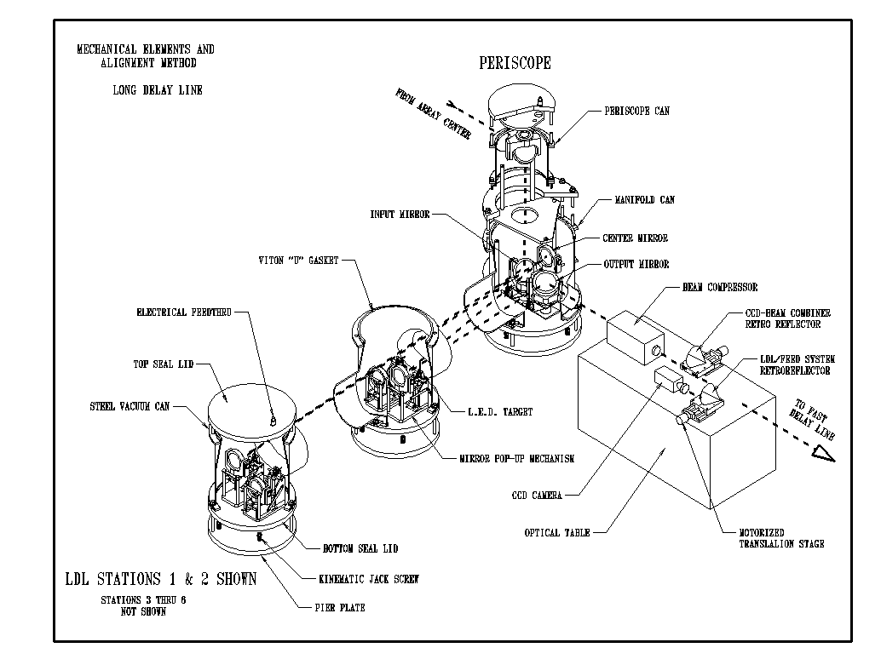

Fig. 4. Typical periscope. Fig. 5. Example of long delay line to periscope interface³.

1.3 Elevators, periscopes, and long delay lines

An elevator consists of a mechanical platform containing either two or three 8-inch diameter flat mirrors, depending on which arm it resides (Fig. 8). The platform is elevated to one of three working levels or a fourth stow level. Only one of these mirrors is remotely adjustable; the other is mechanically aligned prior to assembly on the array. A periscope consists of three 8-inch flat mirrors and one 6-inch flat mirror (Fig. 4). All four periscope mirrors are remotely adjustable. A long delay line station contains two 6-inch flat mirrors, both of which are remotely adjustable (Fig. 5).

1.4 Alignment apparatus (tools)

Along the optical path and in close proximity to each mirror surface in the feed beam system is an alignment target. An alignment target consists of a 3 mm diameter LED on a motorized wand (Fig. 6).

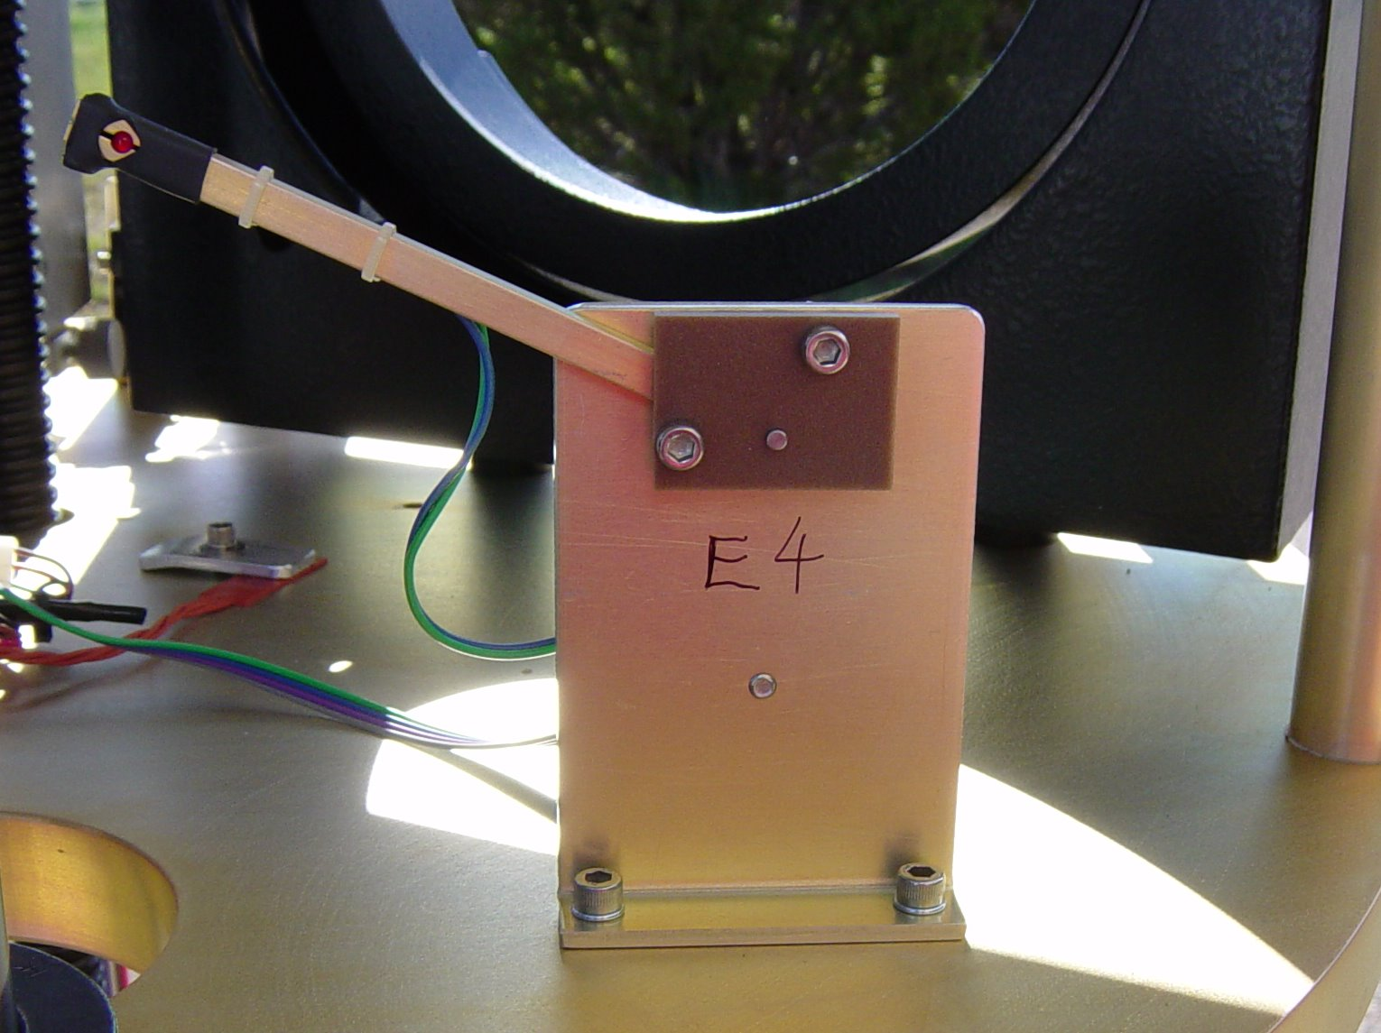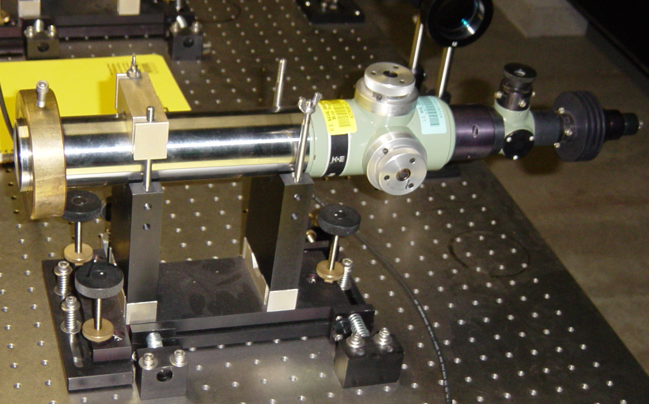

Fig. 6. Motorized LED target. Fig. 7. K&E alignment telescope in v-block.

The alignment telescope used at the NPOI is a K&E Bright Line Alignment Telescope, model 712030, with a focus range between 0 and infinity (Fig. 7). The specifications that follow were taken from K&E manual number 711001. Telescope magnification varies automatically between 4x at zero to 46x at infinity. The effective aperture is 42mm. Resolving power is 3.4 seconds of arc. The field of view is 37 minutes at infinity, and 42mm at zero focus. One of the design characteristics of this telescope is that changes in focus generate negligible changes in optical path sighting. The mount for the alignment telescope is a custom v-block style mount with 5 degrees of precision adjustment: three rotations and two translations (Fig. 7). The longitudinal degree of freedom (direction along the optical axis) is fixed. This mount has long term drift stability and high repeatability for multiple insertions of the alignment telescope. Six v-blocks are permanently mounted in the beam combiner room, at the terminus of the feed beam system. Their locations are such that the feed beam optical path and alignment telescope optical path are collinear. The v-block is designed such that it does not vignette the light beam once the alignment telescope is removed.

TECHNICAL APPROACH
2.1 Alignment methodology

Fundamentally, since all the mirrors in the feed beam system are flat and the light beam is considered collimated, all that is needed to align the system is a clear line of site to the center of the each mirror. A 3mm LED is used as a target to identify the center of each mirror. A series of adjustments are made in sequence such that each mirror is aligned to the next LED in the optical train. Since all six feed beams are aligned similarly we will limit our description to a single beam: beam1, which is the lowest beam extending out to the farthest east-arm elevator target (E10). In order to ensure we are looking along the desired beam path, we developed a custom v-block mount to hold our alignment telescope such that it can operate in either direction (Fig. 7). The telescope is removed from the v-block when the alignment is complete. The v-block exhibits excellent precision and repeatability as has been demonstrated by the infrequent, biannual adjustments required. The v-block is mounted to an optics table, which is located at the terminus of the feed beam system. An alignment laser exists for use in aligning the beam combiner to the fast delay lines. We use this laser as a fiducial-line to position the v-block such that the alignment telescope is collinear with this fiducial-line. The optical center of a laser beam emanating from the detector end of the beam combiner, through the fast delay line, is used as the fiducial line in order to align the telescope. This 1.4-inch diameter beam expands to 5-inch diameter, and continues out to the siderostat once the feed beam system is aligned. It can be used to check for vignetting, and other tests. It follows the same path in reverse as the stellar light beam.

2.2 V-block alignment

The v-block is aligned to this pre-established fiducial line through an iterative and convergent series of adjustments. The beam combiner laser is first attenuated, using appropriate neutral density filters, and allowed to propagate through the beam combiner and fast delay line to the v-block mount. A ring target is installed in close proximity to the v-block such that it is centered on the laser beam. The alignment telescope is installed facing the ring target and laser source. Adjustments in v-block angle are made when focused on the laser source, and translations are made when focused on the ring target. Iteration of this procedure converges on a collinear alignment of the telescope with the fiducial laser beam. With the v-block secured in this final state, the telescope is reversed to look out through the feed beam system.

2.3 Periscope alignment

During the build phase of the periscope, dummy mirrors with marked centers are used to mechanically position the mirror mounts and LED targets. The vacuum canister is not installed and access to the mounts and targets is readily available. The periscope is presently configured for astrometry and is not connected to the long delay lines. The alignment telescope and the human eye are used extensively. As each mount and LED target are positioned, the dummy mirror is removed and an actual mirror installed. The dummy mirror is installed in the next mount along the optical train, and the prior mirror finely adjusted to center on the dummy as seen in the telescope eyepiece. The LED target for this second mirror is then mechanically centered and secured, the dummy mirror swapped for a real one, and the procedure continued. The periscope is considered aligned when its top mirror is adjusted to the far fiducial, E10. The evacuated feed beam pipes, brought from E10 to within a meter of the top periscope mirror, eliminate bending of the target light beam due to changes in index of refraction of air. This allows good pointing of the top mirror to the E10 target. The mechanical positioning and alignments within the periscope are within about 0.25 of an LED diameter, or approximately 0.75 mm of the true center as determined by the human eye through the telescope. This accuracy is primarily due to the close proximity, 10 meters, of the periscope to the alignment telescope. The pointing of the top periscope mirror to E10, 220 meters distant, is within approximately 1.5 LED diameters, or 4.5 mm. Resolution of the target and alignment diminishes with distance. The fiducial line for this feed beam line is defined as the line between the top periscope mirror and E10.

Once the mechanical positioning of the internal periscope mirror mounts and LED targets is accomplished, only occasional alignments, on the order of twice per year, are required. Generally, only the top periscope mirror is adjusted, and mainly due to reconfigurations of the array; such as changing from station E06 to E07.

2.4 Elevator alignment

Elevators are assembled, aligned, and tested in a laboratory setting. The same basic alignment technique as described above in section 2.3 is used, with similar results. After laboratory alignment, the elevator is installed on the array during the build phase. The intermediate elevators, E01 through E09, are positioned nominally along the beam1 line. This fiducial line has been established as the line between the top periscope mirror and E10. All intermediate elevators are globally maneuvered via five degrees of freedom, three rotations and two translations (longitude axis is not adjustable), such that its alignment LED target and optical target are on the telescope cross-hairs (Fig. 8).

Fig. 8. Global elevator alignment.

An elevator is mechanically aligned when its alignment LED is centered on the alignment telescope crosshairs coincidentally with the E10 alignment LED. An optically aligned elevator exists when the narrow angle tracker LED (not shown, but located above the optical target in Fig. 16) and the elevator’s alignment LED are collinear with respect to the alignment telescope crosshairs. As of the date of this writing, elevators E06 and E07 have been aligned using this method with good results: 0.75 LED diameter alignment error.

2.5 Narrow angle tracker to siderostat alignment

Once the feed beam system is aligned from the periscope to the narrow angle tracker (NAT), alignment between the (NAT) and siderostat takes place. This is entirely in air, as the evacuated feed pipe system terminates at a window at the top of the elevator just beneath the NAT. There is presently no LED target associated with the siderostat. A paper target, consisting of a 5-inch diameter cross-hair with circles, is taped to the siderostat cover at the desired location. The siderostat is rotated to its last known retro-reflection position, the beam combiner laser allowed to propagate the entire feed beam system and impinge into the paper target. It must be dark in the vicinity of the target for the human eye to detect the red circular disc. The NAT is aligned so that the laser disc image overlaps concentrically with the paper target circles.

2.6 Alignment tolerances

Tolerances on the alignments are based on two factors: accuracy and repeatability. There are two considerations for accuracy: vignetting of the light beam and the sweet spot of the mirror. Mirror tabs, mount yokes, and support structures within the feed beam system are in close proximity to the light beam. To mitigate vignetting, analysis using computer aided drafting (CAD) software of a 5-inch diameter beam propagating through the system of periscopes, array centers, elevators, and feed pipe, have shown that the accuracy of alignment must be within 0.1-inch radius of the true center of each mirror. Each mirror has a clear aperture (sweet spot) that is 90% of its diameter, concentric with the outside diameter. This is the area of the mirror that is flat to within NPOI specifications. This reduces the useable diameter of an 8-inch mirror to 7.2-inches. Some of the 8-inch mirrors reflect the light at a 45 degree angle (Fig. 17), which further reduces the projected diameter to an equivalent 5.1-inch.

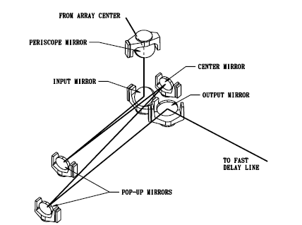

Fig. 9. Beam centerlines of periscope and long delay line. The periscope mirror and input mirror reflect the light beam at 45 degree angles.

The light beam used at the NPOI is 5.0-inches in diameter. This means we must align the mirrors to within 0.05-inch radius of the geometric center; or +/- 0.05-inches, as viewed in the image plane in order for the entire beam to impinge the mirror surface in the sweet spot. It is clear from the above considerations that the accuracy tolerance is driven by the size of the sweet spot. It is helpful to recall that we actually do not align to a mirror, but to an LED target which has been located to represent the exact center of the mirror as viewed from the alignment telescope. Since each LED is 3mm, or 0.125-inch, in diameter, alignment is accurate, with no vignetting and the entire light beam impinges on the sweet spot of the mirror, once the LED and crosshairs are coincident to 0.4 LED diameters. This tolerance holds true regardless of the distance between the LED target and alignment telescope; as long as the target can be resolved.

As far as repeatability is concerned, it is the change in total path length resulting from alignments (either reconfigurations or fine-tune adjustments) that cause a temporal delay in finding fringes during operations. This is because it takes the fast delay lines approximately two minutes of search time for each 10 micrometers of uncertainty in the delay. Once the delay, or position of the fast delay line is known, fringes are obtained quite readily; but if a change in delay is inadvertently introduced, then a hunt and seek routine commences until the new fringe position is found. Analyses of the geometry of the feed beam system indicate that repeatable alignments, on the order of 0.05-inch as required by the accuracy tolerance, result in a change in path length of 1 micrometer. This implies that it will take only 0.17 seconds to find a fringe. Alignment tolerance, therefore, is driven by the size of the sweet spot of the mirror.

ALIGNMENTS AND RESULTS
Using the tools described above (alignment telescope, v-block mount, and human eye as the detector), alignment of the feed beam system occurs during the build, operation, and reconfiguration phases at the NPOI. All feed beam alignment procedures are virtually identical: insert the alignment telescope into the v-block, activate the closet LED target, adjust the alignment telescope to bring the LED into focus, and adjust the mirror which is just prior to the LED in the optical train such that the image of the LED is centered on the alignment telescope crosshairs within 0.4 LED diameters. Since the human eye is the detector, this is a qualitative measurement. For example, when aligning the periscope, which is 12 meters from the alignment telescope, the LED image is rather large in the eyepiece and a 0.4 LED diameter is readily discernable (Fig. 10). When the E02 elevator is aligned, 60 meters distant, the LED image is somewhat smaller, but 0.25 LED diameters is easily obtainable. When we align E06 or E07 elevators, the LED image in the eyepiece is at best resolved to 0.5 LED diameters (Fig. 11). When peering at the E09 LED, the focused image is so small it hides behind the crosshairs; thus, it is necessary to defocus the image to view the LED location (Fig. 12). A primary check for successful system alignment is to check for any vignetting of a 5-inch laser beam after it has passed through the system. This is achieved by inspecting the beam for any shadows (vignetting) at the siderostat.

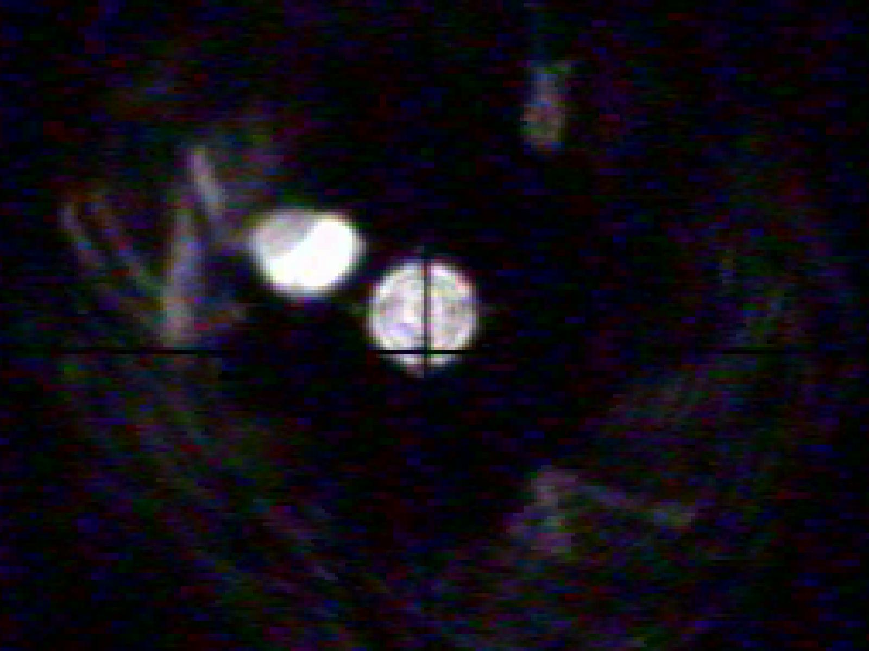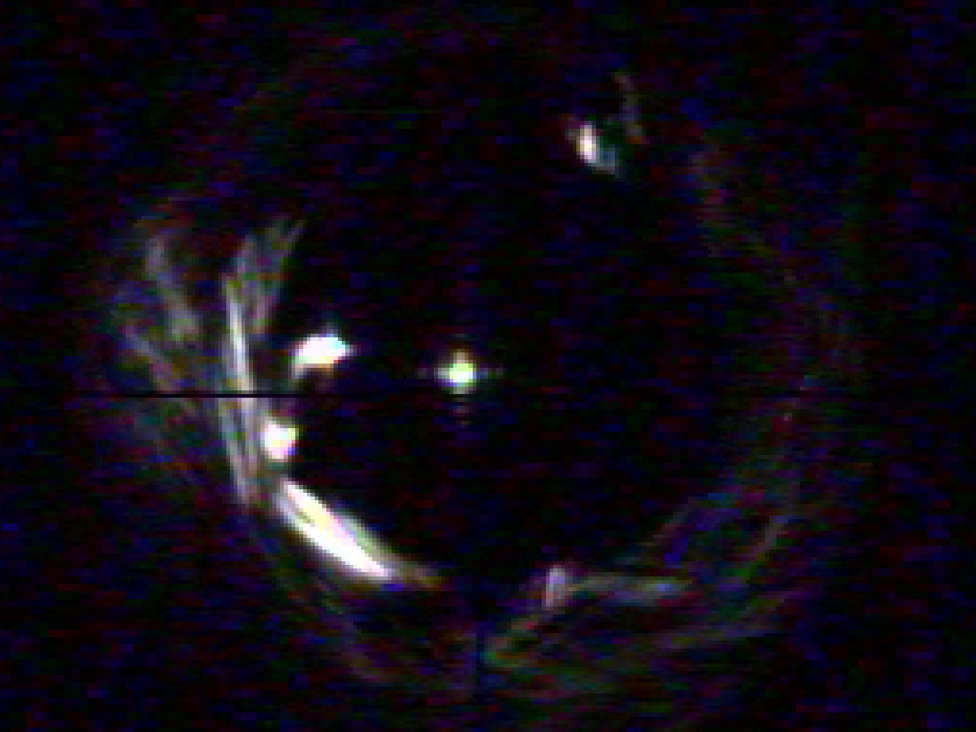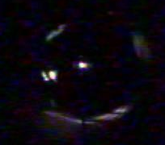

Fig. 10. Periscope LED. Fig. 11. E06 LED target. Fig. 12. E09 LED target (out of focus).

During drift and repeatability experiments on the long delay lines a charge-coupled device (CCD) camera replaced the alignment telescope eyepiece. The image, 110 meters distant, appeared as shown in Fig. 13. The CDD image is included in this paper as a possible enhancement to the tools and techniques presently in use. Although beyond the scope of this paper, the technique appears promising. There are, however, a number of limitations with the current CCD adaptation. First, noise levels appear to be obscuring the data such that the image location appears to jump around in space. Second, our centroiding software is not advanced enough to compensate for the dark crosshairs passing through the LED; hence, the software often produced incorrect numbers.

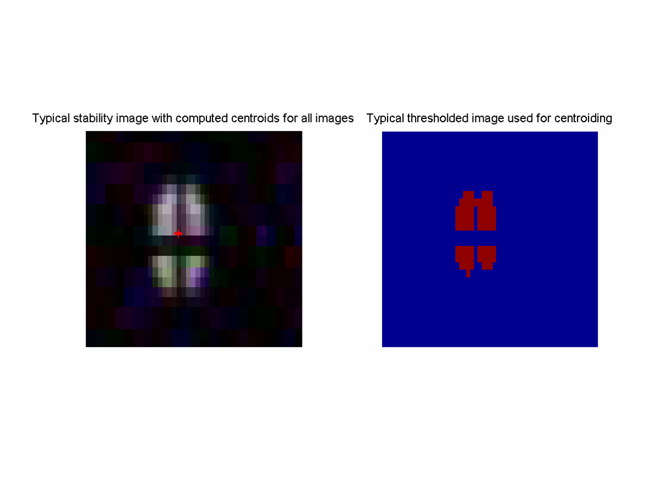

Fig. 13. In-Focus aligned and zoomed periscope 1 to E06.

CONCLUSIONS
We analyzed and determined alignment tolerances based on accuracy and repeatability. Accuracy, offset from the geometric center of the mirror, determines whether vignetting will occur and/or whether a portion of the 5.0-inch diameter light beam will be off the sweet spot of the mirror. CAD analysis shows vignetting occurs if the alignment is off center by approximately 0.2 inch. The sweet spot of an 8-inch diameter mirror at 45 degree reflection is 5.1-inch, and therefore the alignment needs to be within 0.05 inch of the center. Repeatability is not an issue as long as the accuracy of 0.05 inch can be met. The tools and techniques presently employed for aligning the feed beam system at the NPOI are satisfactory for preventing vignetting, and fair assurance the alignment tolerance is met out to a distance of about 100 meters (the E07 elevator station). However, distances greater than 100 meters may require new tools & techniques such as utilizing centroiding software and CCD cameras in order to achieve the desired results.

ACKNOWLEDGEMENTS

The authors thank the Oceanographer of the Navy and the Office of Naval Research for support of the Navy Prototype Optical Interferometer.

REFERENCES

- J. T. Armstrong, D. Mozurkewich, L. J. Rickard, D. J. Hutter, J. A. Benson, P. F. Bowers, N. M Elias II, C. A. Hummel, K. J. Johnston, D. F. Buscher, J. H. Clark III, L. K. Ha, L.-C. Ling, N. M. White, and R. S. Simon, “The Navy Prototype Optical Interferometer,” Astrophysics J. 496, pp. 550-571, 1998.
- J. A. Benson, C. A. Hummel, and D. Mozurkewich, “Simultaneous 6-station observations with the NPOI,” Proc. of SPIE, Vol. 4838, 2003 SPIE-0277-786X/03, 2003.
- J. H. Clark III, L. Ha, D. Mozurkewich, and J. T. Armstrong, “Design of the long delay lines for the Navy Prototype Optical Interferometer,” in Astronomical Interferometry, R.D. Reasenberg, ed., Proc. SPIE 3350, pp. 497-504, 1998.
- J. H. Clark, III, J. Murphy, L. Ha, J. P. Walton, J. Howard, J. T. Armstrong, G. C. Gilbreath, R. B. Hindsley, and T. A. Pauls, “Optical drift test of the long delay line stations on the Navy Prototype Optical Interferometer”, in New Frontiers in Stellar Interferometry, Proc. SPIE AS04-AS03-137, 2004.

 jhc@sextans.lowell.edu; phone 1 928 779-5132; fax 1 928 774-3626

